E-Commerce Sales Analysis
Observation – Power BI Assignment 2: DAX & Data Visualization
1. Project Overview
This project focused on analysing e-commerce sales data using Power BI by applying data modelling, DAX calculations, and interactive visualizations. The objective was to transform raw sales data into meaningful business insights that support decision-making and performance evaluation.
2. Data Sources Used
The analysis was performed using the following datasets:
★ List of Orders
★ Order Details
★ Sales target

Data Transformation Process:
- Imported the List of Orders, Order Details, and Sales Target datasets into Power BI

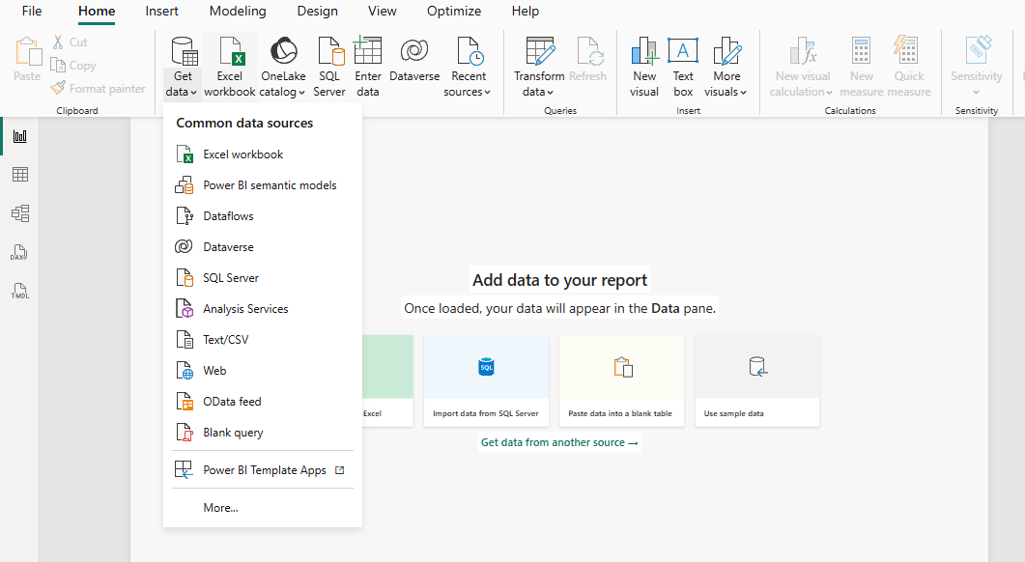
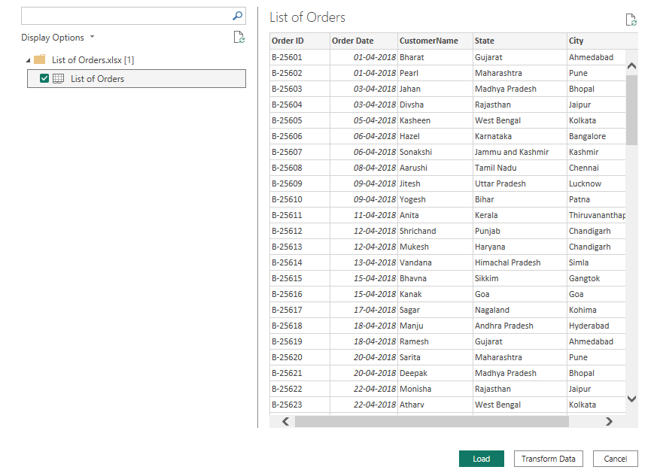

Data Modelling:

- Verified the Data Set and No duplicates and missing values found.
- Establish a relationship between the “List of Orders” and “Order Details” tables using the ‘Order ID’ column.

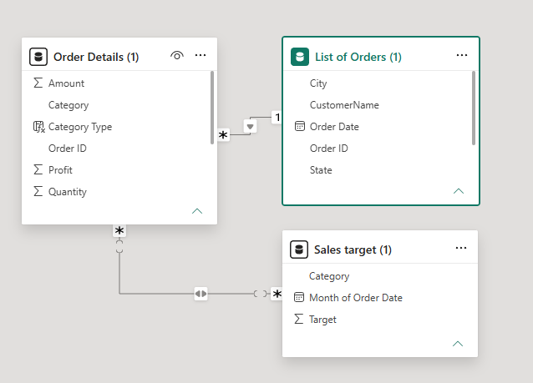

DAX Calculated Columns
Category Type
A calculated column was created by combining Category and Sub-Category fields to provide a more detailed product classification.
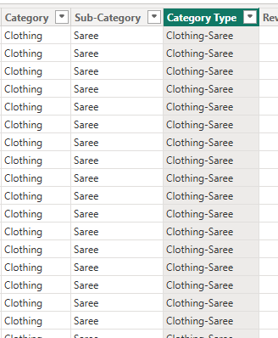

Revenue per Order
A new column was created to calculate revenue generated per order using the formula
Revenue = Amount × Quantity
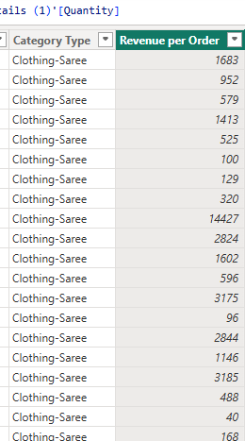

Sales Category
Orders were categorized as Above Average or Below Average based on their sales amount relative to the average sales value.
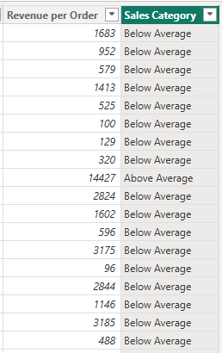
DAX Measures
Order Count
A measure was developed to calculate the total number of orders processed in the dataset.
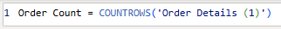
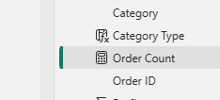
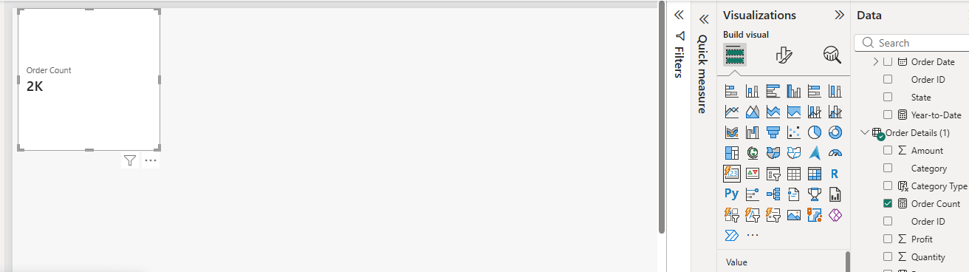

Average Profit in Delhi
A DAX measure was created to determine the average profit generated from orders placed in Delhi.
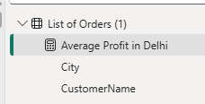
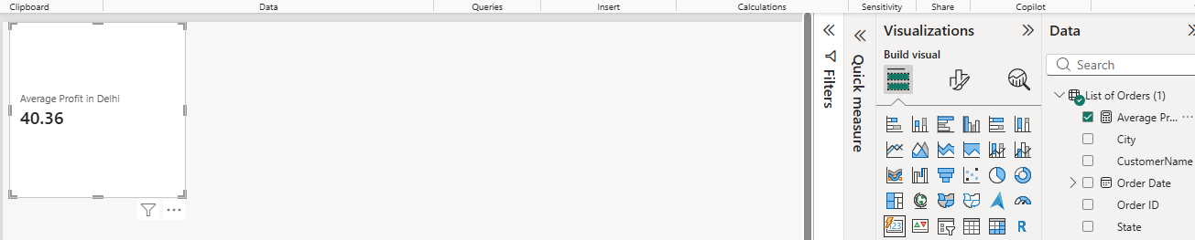

Year-to-Date (YTD) Sales
A cumulative sales measure was developed to track total sales from the beginning of the year up to each transaction date.
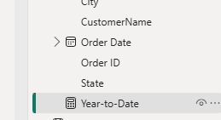
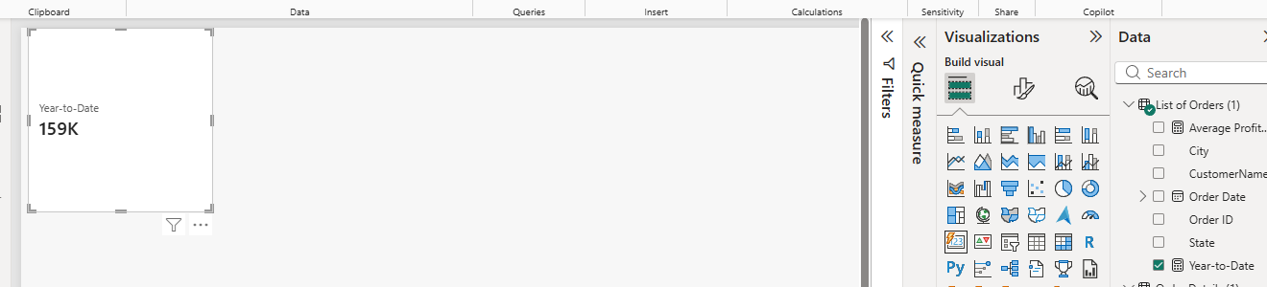

Data Visualizations
Sales Target Achievement by Category
A clustered column chart was used to compare actual sales with target sales across different product categories.
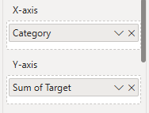
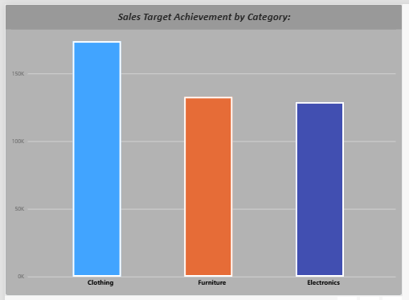

Maximum Profit Margin by Sub-Category
A donut chart was created to identify sub-categories contributing the highest profit margins.
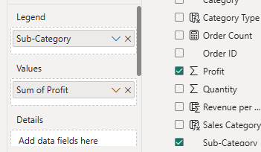
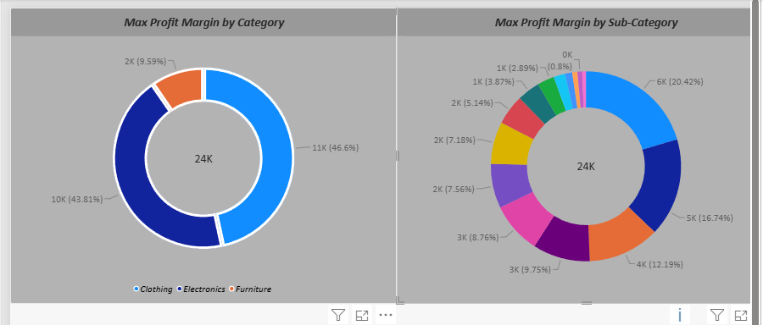

Monthly Sales Trend
A line chart displayed monthly sales performance and highlighted overall sales trends over time.
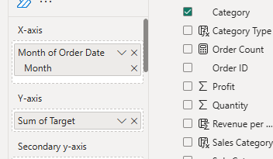

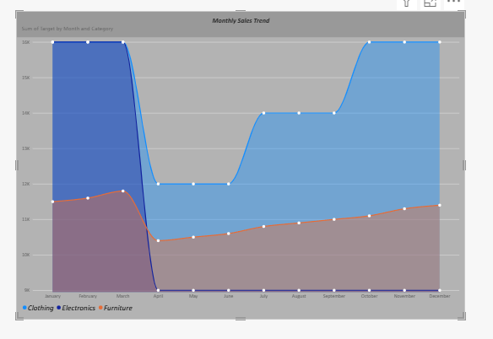

Profit vs Quantity Analysis
A scatter chart was used to examine the relationship between profit earned and quantity sold for different product sub-categories.
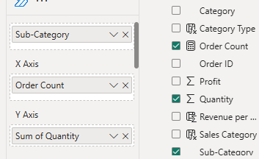

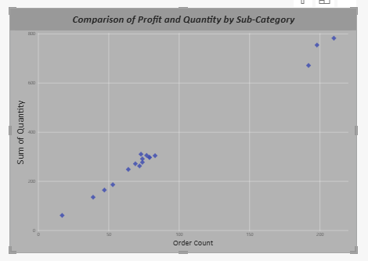

Total Sales and Target Comparison
Card visuals were designed to display total sales amount and target values for quick performance monitoring.
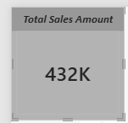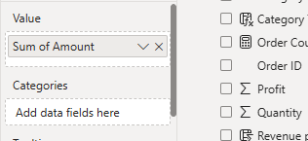
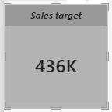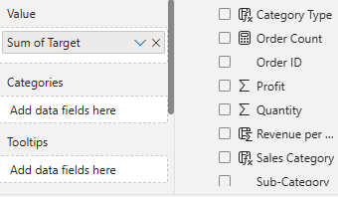

Minimum Target Analysis
A multi-row card was used to present the minimum sales target for each customer segment.
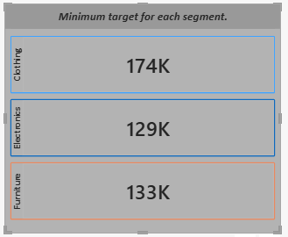
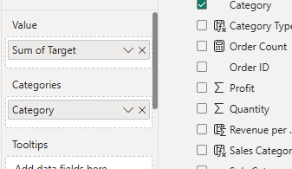

Sales Performance Matrix
A matrix visualization provided a detailed comparison of actual sales against target sales by category and month.

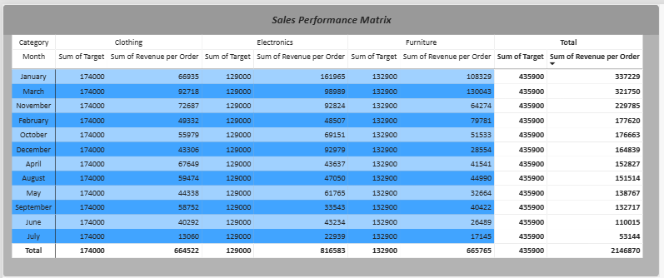
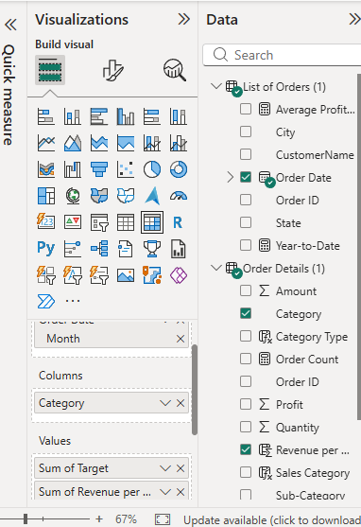

Geographic Sales Analysis
A map visualization was developed to analyse city-wise sales performance and identify regional sales patterns.
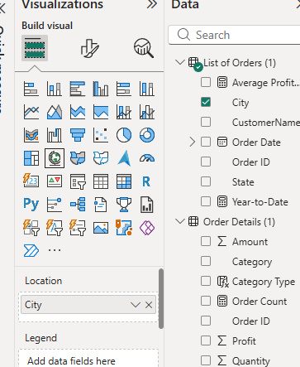

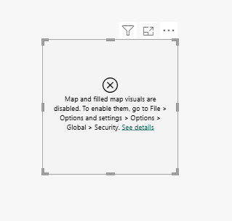
Due to an Error I came up with this Result, also adjusted the setting as mentioned but same results.

Sales Distribution by Sub-Category
A tree map visual displayed the contribution of different sub-categories to total sales.
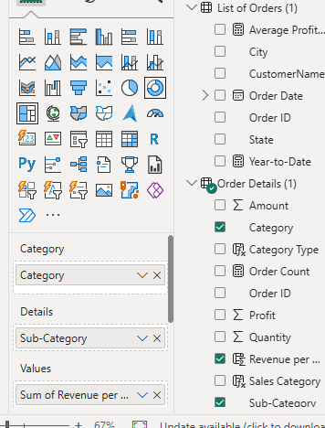

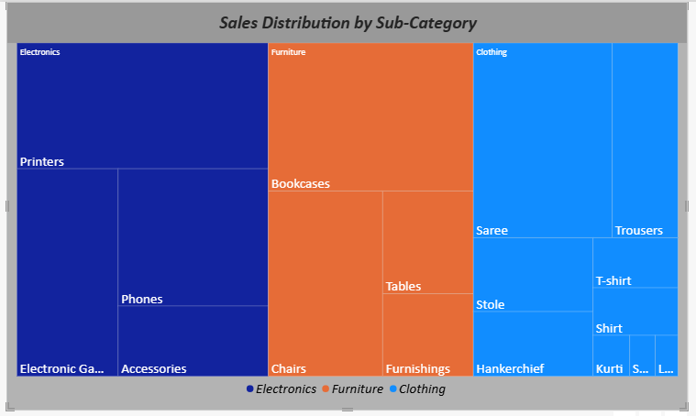
Order Count Analysis by State
A funnel chart illustrated the distribution of order counts across various states.
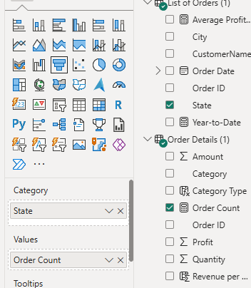

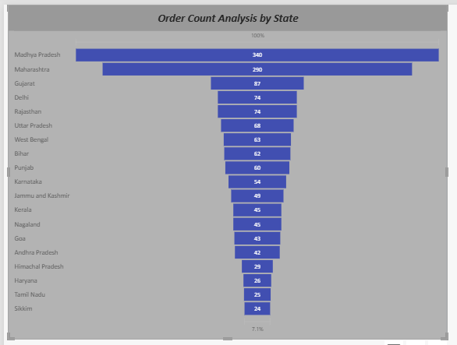

Conclusion
This project successfully demonstrated the use of Power BI for data modelling, DAX calculations and visualization development. The dashboard transformed raw e-commerce data into meaningful insights, enabling users to monitor sales performance, analyse profitability, track targets, and make data-driven business decisions effectively.

